**Introduction to Relational Databases in SQL**

# **Tables**

## **Query information schema tables**: information about all tables in database

SELECT table_name

FROM information_schema.tables

WHERE table_schema = 'public';

## 

## **Query information schema columns**: information about all columns in all tables

SELECT column_name, data_type

FROM information_schema.columns

WHERE table_name = 'table_name'

AND table_schema = 'public';

## 

## **Creating simple tables:**

CREATE TABLE table_name (

column_a data_type,

column_b data_type,

column_c data_type

);

## 

## **Adding column names:**

ALTER TABLE table_name

ADD COLUMN column_name data_type;

## 

## **Insert distinct records from a table to a table:**

INSERT INTO target_table

SELECT DISTINCT column_a, column_b

FROM source_table

## **Insert distinct records into a table:**

INSERT INTO table_name (column_a, column_b)

VALUES (“value_a”, “value_b”)

## **Rename a column:**

ALTER TABLE table_name

RENAME COLUMN old_name TO new_name

## **Drop a column:**

ALTER TABLE table_name

DROP COLUMN column_name

## 

## **Drop table:**

DROP TABLE table_name

## **Update table:**

UPDATE table_name

SET col_name = CONCAT (a, b);

## **Join tables:**

SELECT ...

FROM table_a

JOIN table_b

ON …=...

WHERE …

-- Select all professors working for universities in the city of Zurich

SELECT professors.lastname, universities.id, universities.university_city

FROM professors

JOIN universities

ON professors.university_id = universities.id

WHERE universities.university_city = 'Zurich';

## **Update columns of a table based on values in another table:**

UPDATE table_a

SET column_to_update = table_b.column_to_update_from

FROM table_b

WHERE condition1 AND condition2 AND ...;

This query does the following:

1. For each row in table_a, find the corresponding row in table_b where condition1, condition2, etc., are met.
2. Set the value of column_to_update to the value of column_to_update_from (from that corresponding row).
3. The conditions usually compare other columns of both tables, e.g. table_a.some_column = table_b.some_column. Of course, this query only makes sense if there is only *one* matching row in table_b.

# **Attribute Constraints – e.g. data types on columns.**

## **Type Cast**

CREATE TABLE weather (

temperature integer, wind_speed text);

SELECT temperature * CAST(wind_speed AS integer) AS wind_chill

## **Common Data Types**

text

varchar [ (x) ] – max x characters

char [ (x) ] – fixed length string of x characters

boolean – TRUE, FALSE, NULL (unknown)

date, time, timestamp

numeric [ (x, y) ] - precision of x and scale of y (total x digits and y digits after .)

integer – whole numbers

serial - allows incrementing numbers in existing table in PostgreSQL

## **Alter data type**

ALTER TABLE table_name

ALTER COLUMN column_name

TYPE new_dtype

## **Truncate or transform values before altering**

ALTER TABLE table_name

ALTER COLUMN column_name

TYPE new_dtype

USING some_function (column_name)

## **Example – Convert types using a function**

ALTER TABLE table_name

ALTER COLUMN column_name

TYPE varchar(x)

USING SUBSTRING(column_name FROM 1 FOR x)

*Because you want to reserve only x characters for column_name, you have to retain a SUBSTRING of every value, i.e. the first x characters of it, and throw away the rest. This way, the values will fit the varchar(x) requirement.*

## **Add or Remove Not-Null constraint**

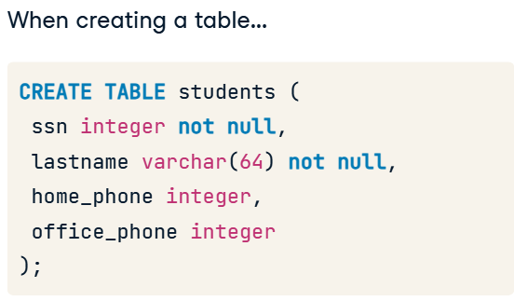

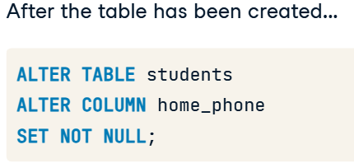

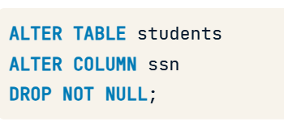

## **Adding Unique constraint – name the constraint**

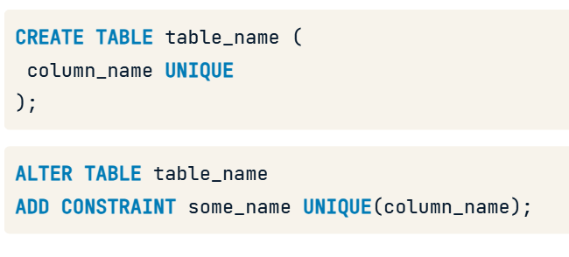

# **Key Constraints - e.g. primary keys.**

**Keys are denoted by underlined attribute names in the entity-relationship diagram**

## **Keys, superkeys and candidate keys**

* The combination of all attributes is a key in itself.
* However, it's not called a key, but a superkey, if attributes from that combination can be removed, and the attributes still uniquely identify records.
* If all possible attributes have been removed but the records are still uniquely identifiable by the remaining attributes, we speak of a minimal superkey.
* This is the actual key. So a key is always minimal.

## **Identify keys with SELECT COUNT DISTINCT**

1. Count the distinct records for all possible combinations of columns. If the resulting number x equals the number of all rows in the table for a combination, you have discovered a superkey.
2. Then remove one column after another until you can no longer remove columns without seeing the number x decrease. If that is the case, you have discovered a (candidate) key.

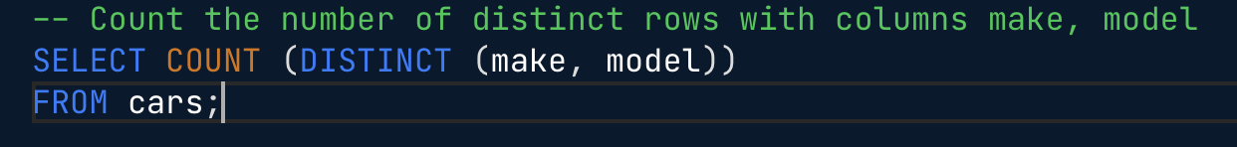

## **Primary keys**

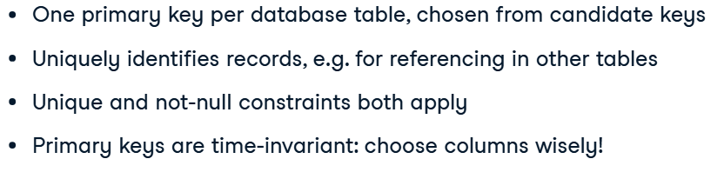

## **Specify Primary Key**

## 

## 

## **Surrogate Key**

* Artificial primary key - not based on a native column in data, but on a column that just exists for the sake of having a primary key.
* A primary key is ideally constructed from as few columns as possible and should never change over time.
* Defining an artificial primary key (ideally consisting of a unique number or string) - can be sure that this stays the same for each record.
* Other attributes might change, but the primary key always has the same value for a given record.

## **Add surrogate key**

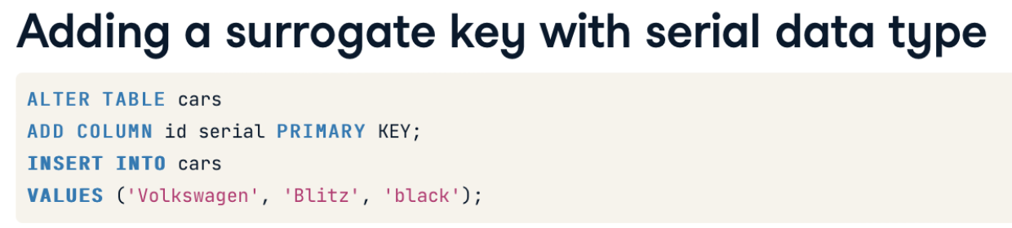

## 

## 

## 

## 

## **Another type of surrogate key**

* Combine two existing columns into a new one.
* In this example, ADD new column with the "varchar" data type.
* UPDATE that column with the concatenation of two existing columns.
* (CONCAT function concatenates values of two or more existing columns).
* Turn that new column into a surrogate primary key.

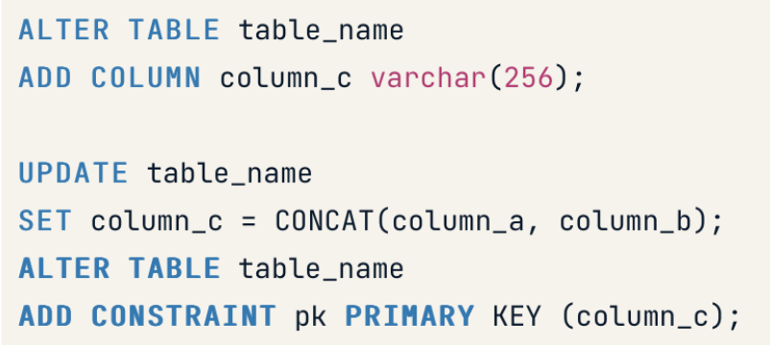

-- Count the number of distinct rows with columns make, model

SELECT COUNT(DISTINCT(make, model))

FROM cars;

-- Add the id column

ALTER TABLE cars

ADD COLUMN id varchar(128);

-- Update id with make + model

UPDATE cars

SET id = CONCAT(make, model);

-- Make id a primary key

ALTER TABLE cars

ADD CONSTRAINT id_pk PRIMARY KEY (id);

# **Referential integrity Constraints – enforced through foreign keys.**

* A record referencing another record in another table must always refer to an existing record.
* In other words: A record in table A cannot point to a record in table B that does not exist.
* Referential integrity is held from A to B.
* Referential integrity is a constraint that always concerns two tables, and is enforced through foreign keys,

## **1:N relationships with foreign keys**

**Drawn with a rhombus in the Entity Relationship Diagram**

**small numbers denote cardinality**

## 

## **Foreign Keys - REFERENCES keyword**

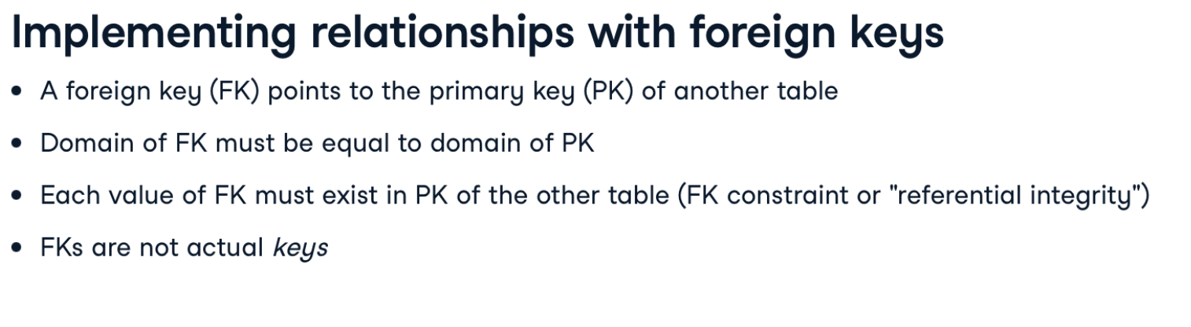

## **Specify foreign key**

**naming convention** employed here: Usually, a foreign key referencing another primary key with name id is named x_id, where x is the name of the referencing table in the singular form.

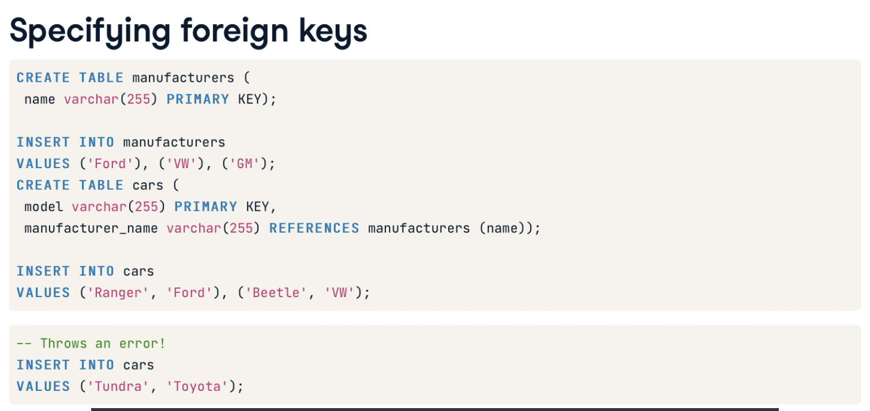

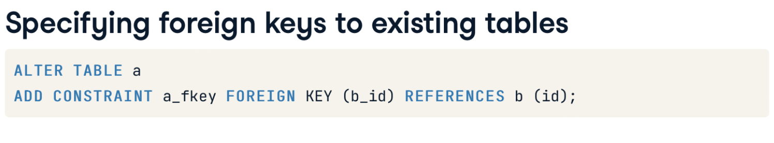

## **N:M relationships with foreign keys**

**Drawn with an oval in the Entity Relationship Diagram**

## **Implement N:M_relationships**

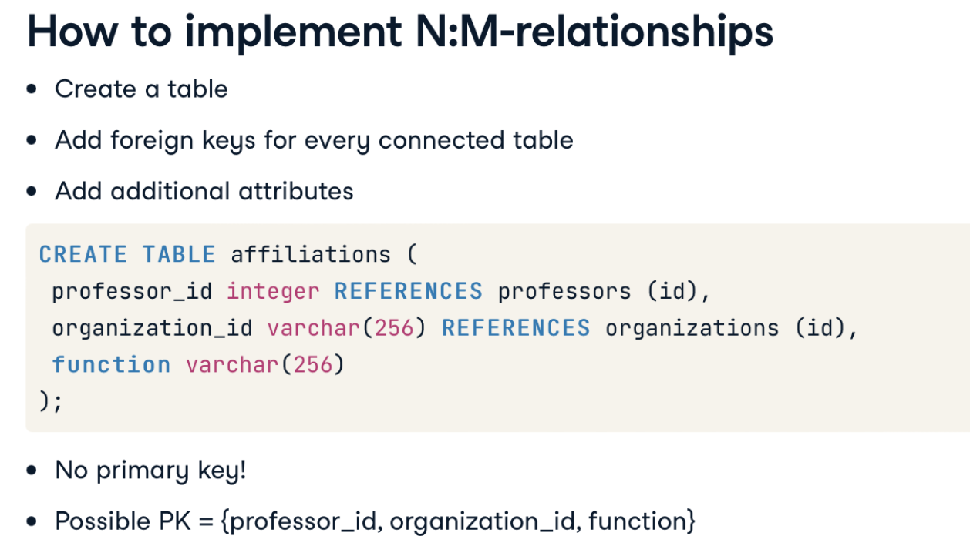

## **Referential Integrity Violations**

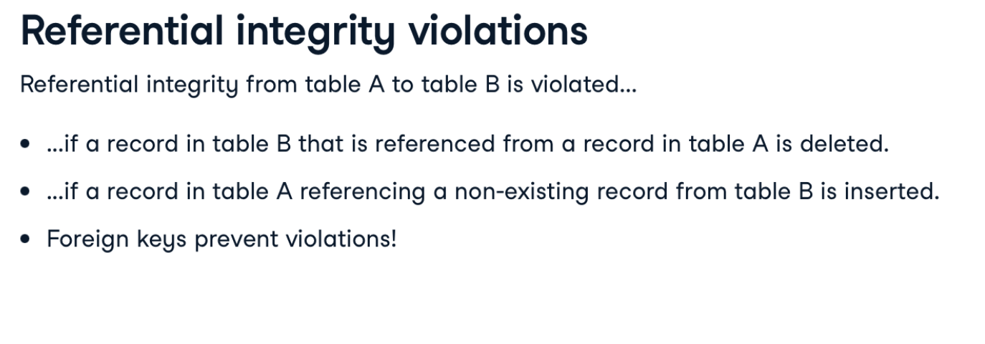

## **Dealing with violations**

ON DELETE NO ACTION IS DEFAULT

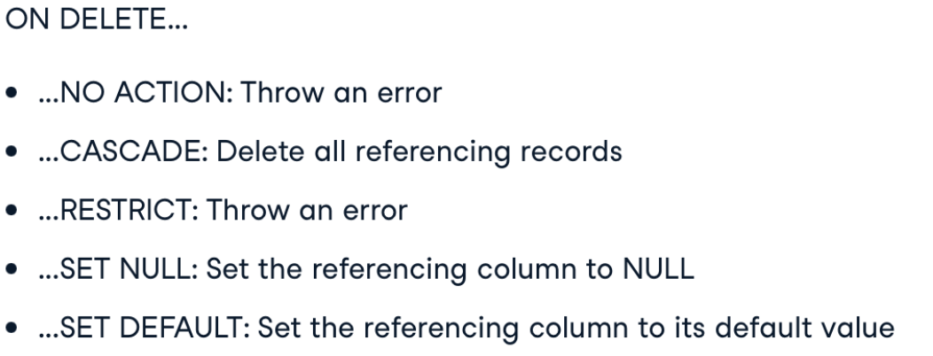

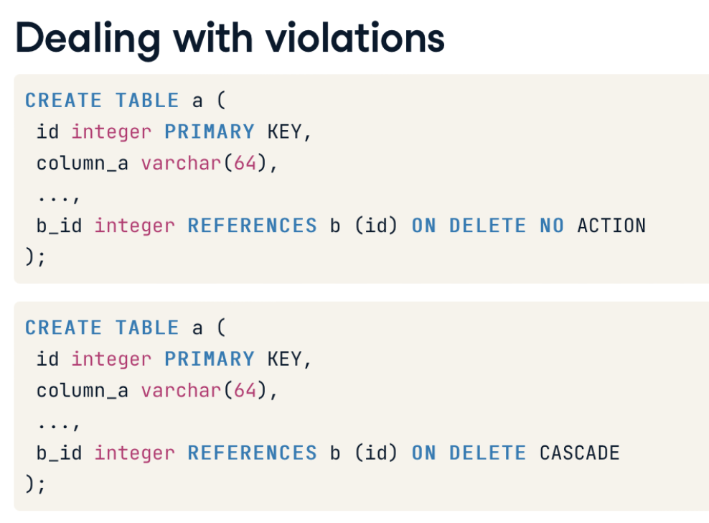

# **Identify constraints from table schema**

## **Identify the correct constraint name**

SELECT constraint_name, table_name, constraint_type

FROM information_schema.table_constraints

WHERE constraint_type = 'FOREIGN KEY';